After the Webpage, add another webpage: Name: **Input-Output and Interrupt**

Link: <https://www.studytonight.com/computer-architecture/addressingmodes-instructioncycle>

**Input-Output and Interrupt**

A computer can serve no useful purpose unless it communicates with the external environment. Instructions and data stored in memory must come from some input device. Computational results must be transmitted to the user through some output device. Commercial computers include many types of input and output devices.

**Input-Output Configuration**

The terminal sends and receives serial information. Each quantity of information has eight bits of an alphanumeric code. The serial information from the keyboard is shifted into the input register INPR. The serial information for the printer is stored in the output register OUTR. These two registers communicate with a communication interface serially and with the AC in parallel.

The input-output configuration is shown in the figure down below. The transmitter interface receives serial information from the keyboard and transmits it to INPR. The receiver interface receives information from OUTR and sends it to the printer serially.

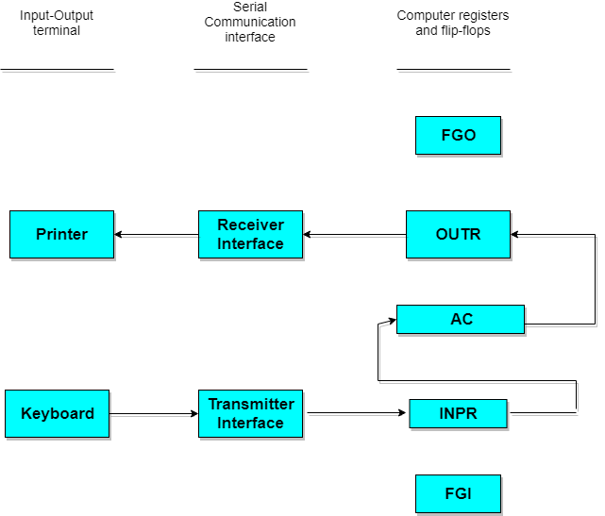

**Input-Output Configuation**

**Program Interrupt:**

The process of communication just described is referred to as programmed control transfer. The computer keeps checking the flag bit, and when it finds it set, it initiates an information transfer. The difference of information flow rate between the computer and that of the input-output device makes this type of transfer inefficient.

An alternative to the programmed controlled procedure is to let the external device inform the computer when it is ready for the transfer. In the meantime, the computer can be busy with other tasks. This type of transfer uses the interrupt facility. While the computer is running a program, it does not check the flag has been set. The computer deviates momentarily from what it is doing to take care of the input or output transfer. It then returns to the current program to continue what it was doing before the interrupt.

**Interrupt Cycle:**

The interrupt cycle is a hardware implementation of a branch and save return address operation. The return address available in PC is stored in a specific location where it can be found later when the program returns to the instruction at which it was interrupted. This location may be a processor register, a memory stack, or a specific memory location.